Angol CV minta ápolók számára

Personal data:
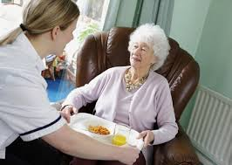 | Candidate name | Carer
 | Phone | 0123456789
 | Email | carer@gmail.com
 | Age | 40 | Date of birth | 17/06/1975
 | Marital status | Unmarried
 | Children | 2
 | Driving license (Y/N) | Y | Category |  | B | Valid since | 2012
Profession | Carer |  | Years of experience |  | 11
Language skills level (beginner, medium, advanced) | Russian-beginner  Italian-beginner  English-conversational
Certificates (by profession) | HTP Newport Isle of Wight UK
Availability | After 10 November 2015

Employment history:

Period | Employer | Country | Position | Web site
2014-2015 | Xyz | Italy | Care assistant | -
2012-2014 | Carer home | Italy | Supervisor | -
2006-2008 | BDE | UK | Waitress,Supervisor | -
2005-2006 | Abcx | UK | Waitress,Supervisor | -

Summary of activities performed at the above employers:
Relevant information of tasks worked on at employers:

- tooking care of the elderly persons surround them with love and attention to
- getting to know clients, their interests and their needs
- helping pacients with daily personal care such as washing, dressing, using the toilet and feeding themselves
- carrying out general tasks such as housework, laundry and shopping
- helping families get used to new caring responsibilities
- helping to organise leisure activities

Education:
1982-1992 school Mingir Moldova
1992-1996 UTM

Reference: ( Name – function- phone N. / or letter of recommendation)

