Angol CV minta autóbusz szerelők számára

Personal data:
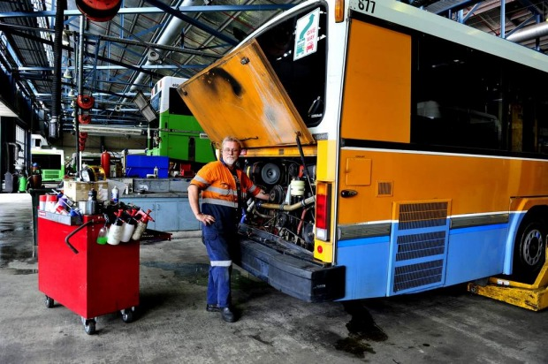 | Candidate name | Bus Mechanic
 | Phone | 0123456789
 | Email | busmechanic@gmail.com
 | Age | 43 | Date of birth | 17/06/1972
 | Marital status | Married
 | Children | 1
 | Driving license (Y/N) | Y | Category |  | B,C,D,E | Valid since | B since 05/1999  C, D, E since 06/2007
Profession | Bus Mechanic |  | Years of experience |  | 7
Language skills level (beginner, medium, advanced) | English- Medium
Certificates (by profession) | Mechanic Certificate
Availability | 2 weeks after acceptance

Employment history:

Period | Employer | Country | Position | Web site
Sept 2002 – Present | Xyz | Hungary | TrucK Mechanic Team Leader
January 2013 - January 2015 | ABC | Kurdistan | Maintenace Technician
July 2000 – August 2002 | YYU | Italy | Mechanical services
1997 – 2000 | Bde | Romania | Mechanical services

Summary of activities performed at the above employers:
Relevant information of tasks worked on at employers:

- providing truck repairing (brands such as Iveco, MAN, Mercedes )
- repairing trucks and trailers regarding the hydraulic aspects, mechanical, electrical and pneumatic
- realizing maintenance and servicing the engines.
- Directly responsible of defective parts ordering
- Directly responsible of assembly and disassembly defective systems (brake, steering, suspension )
- Directly responsible of engine (oil and filters)
- Directly responsible of transmission
- Removing defective parts
- Cleaning engine assemblies
- Keeping tools clean and ready for work
- Directly responsible of tinware (welding, painting )
- repairing the truck damages
- repairing malfunctioning components, retrofit engines, change brakes, adjust steering systems, replace
- worn-out parts and change hydraulic fluids
- Using welding torches, pneumatic wrenches, hydraulic jacks,
- screwdrivers, pliers, mallets and precision gauges
- performing routine maintenance such as changing oil, checking batteries, and lubricating equipment and
- machinery
- using handtools such as screwdrivers, pliers, wrenches, pressure gauges, and precision instruments, as well
- as power tools such as pneumatic wrenches, lathes, welding equipment, and jacks and hoists

Education:
Period: 08/1987 - 05/1989
Name of organization: XYZ High School, Vocational School
Orientation: Electrotechnician

Reference: ( Name – function- phone N. / or letter of recommendation)

